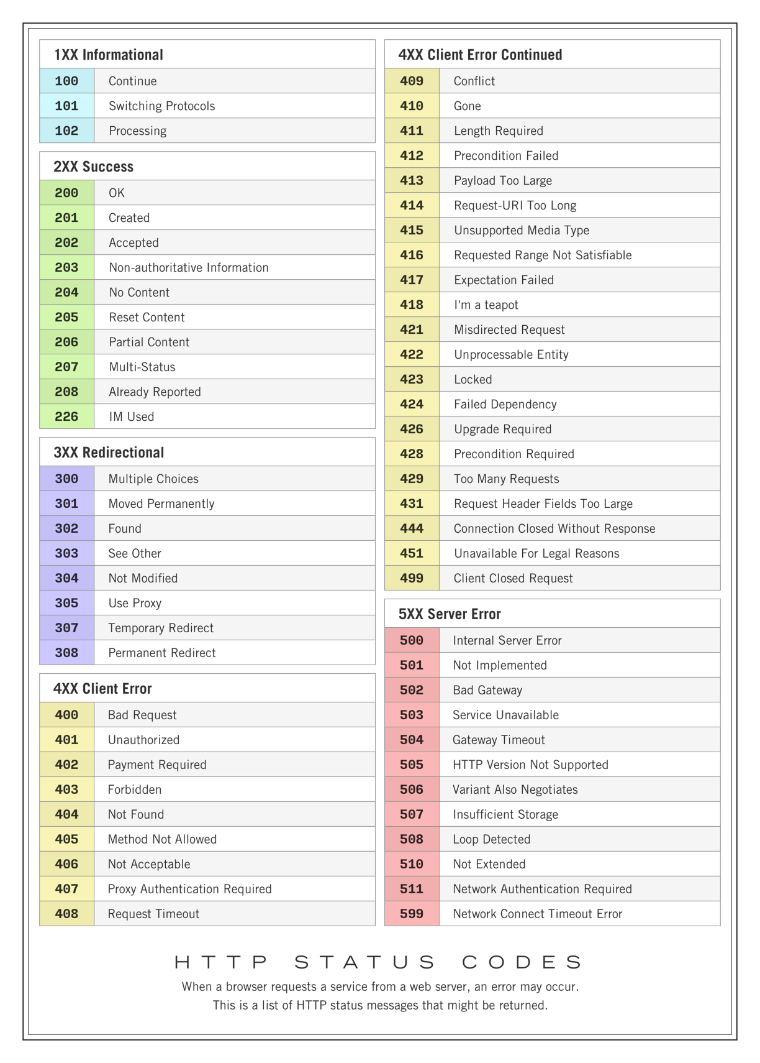

# Types of requests

## GET:

* The GET method is used to request data from a specified resource.
* It's commonly used for fetching data from a server.
* Parameters are sent in the URL's query string.
* GET requests can be cached, bookmarked, and are idempotent (multiple identical requests have the same effect as a single request).
* Example: Fetching a list of products from a database.

## POST:

* The POST method is used to submit data to be processed to a specified resource.
* It's commonly used for creating new resources on the server.
* Parameters are sent in the request body.
* POST requests are not cached, cannot be bookmarked, and are not idempotent.
* Example: Submitting a registration form.

## PATCH:

* The PATCH method is used to apply partial modifications to a resource.
* It's commonly used for updating parts of an existing resource.
* Parameters are sent in the request body.
* PATCH requests are not cached, cannot be bookmarked, and are not guaranteed to be idempotent.
* Example: Updating the status of an order without changing other details.

## PUT:

* The PUT method is used to replace all current representations of the target resource with the request payload.
* It's commonly used for updating or replacing an existing resource.
* Parameters are sent in the request body.
* PUT requests are not cached, cannot be bookmarked, and are idempotent.
* Example: Replacing an existing user's data with new data.

## Day 7 highlights

### How to create the post request that will take json from postman or thunderclient and populate our database with thee data given with reference to the schema model we provided with separate connection file to the database that must be imported in main file

Steps

1. Create database in mongodb atlas with copying the credentials it provided alongside our device IP address must be given to access it
2. Use that credential given in connection file to asynchronously connect to the database
3. Create database model to be abided while inserting the data
4. Import all the elements that has been created while using express.json() and urlencoded to parse the request from json file or encoded data format
5. In createblog endpoint destructuring the data from the body and populate the database